# Color Theory in Practice

Color shapes our experience of spaces. It affects our mood, defines different areas, and subtly reveals the designer's intentions.

## 1. Color Fundamentals

### Color Properties: Beyond the Basics

Your HNC studies will dive into the color wheel thoroughly, but let's focus on the subtle qualities that actually impact how colors look in real spaces:

* **Hue**: The color itself (red, blue, yellow, etc.)
* **Value**: How light or dark a color appears
* **Saturation**: The intensity or purity of a color
* **Undertones**: Those hidden underlying tints that show up under different lighting

Here's what these look like in everyday life:

* **Hue**: Think of a cherry red sports car - that's a vibrant red hue.
* **Value**: A deep burgundy leather sofa is lower in value (darker) than bright red.
* **Saturation**: The vivid yellow of a sunflower has high saturation, while an old mustard armchair looks more muted (lower saturation).
* **Undertones**: Ever painted a wall beige only to discover it looks oddly pink or green? That's the undertones revealing themselves in your specific lighting.

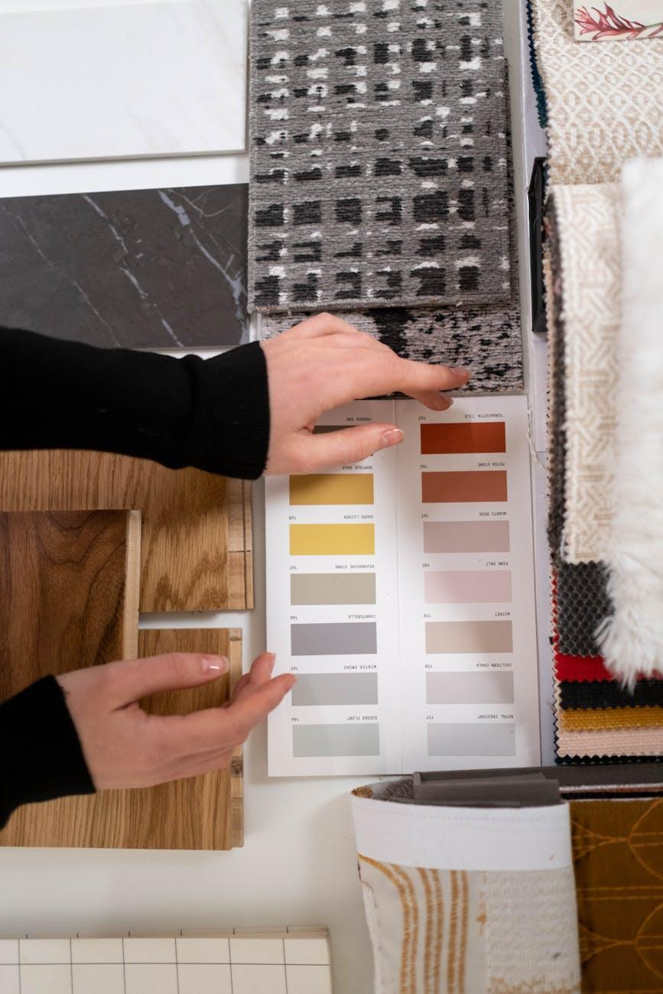

Fig.1 (cottonbro studio on [Pexels](https://www.pexels.com/photo/6579994/), 2025) Color property variations showing how the same color hue transforms when its value and saturation are adjusted, demonstrating why understanding these properties matters when selecting interior colors.

**Try This when exploring color variations around you:** A light blue wall with warm undertones (low saturation, high value) feels completely different than a deep navy blue wall with cool undertones (low saturation, low value). Getting these subtle distinctions right makes all the difference in creating your desired mood. Snap a photo of a space where color dramatically impacts the atmosphere.

### Color Schemes: The Why Behind Design Choices

Instead of just defining color relationships, let's examine when and why designers pick specific schemes:

* **Monochromatic**: Creates a clean, unified look; great for smaller spaces or when highlighting texture variations
* **Analogous**: Delivers a harmonious, calming feel; perfect in spaces meant for relaxation
* **Complementary**: Generates energy and visual contrast; great for emphasizing architectural features or creating focal points
* **Split-complementary**: Offers visual interest without the intensity of complementary schemes; works well in multi-purpose spaces
* **Triadic**: Creates a vibrant, balanced feel; good for creative areas or spaces meant to spark conversation

**Try This when looking at designed spaces:** Find three interior photos you're drawn to. For each, identify the color scheme and think about why the designer chose it for that particular space. How does it support the room's function and mood? Notice which schemes naturally match what you like. Write down which scheme feels most in tune with your personal style.

## 2. Application Methods

### The Impact of Light and Orientation

Light transforms how we see color, which is why seasoned designers never pick colors without considering the room's orientation and lighting. That perfect paint color in the store might look totally different on your walls at home.

Designers always think about how light affects color appearance:

* North-facing rooms get cooler, more consistent light that tends to make colors look more muted
* South-facing rooms receive warm, direct light that can intensify colors
* East-facing rooms enjoy bright morning light that shifts dramatically throughout the day
* West-facing rooms get warm afternoon light that can create strong shadows

**Try This at different times of day in your home:** Take three color samples. Place them in different spots around your home with varying light conditions. Look at how they change at different times of day (morning, midday, evening). You'll be amazed how much the same color shifts depending on light and orientation. Take photos to reference when choosing colors for future projects. Jot down which lighting condition creates your favorite effect.

### The Professional Selection Process: 60-30-10 Rule

When you step into a well-designed room, you might not immediately notice the careful balance of colors, but you'll definitely feel it. Many designers use a proven formula to create balance while avoiding the mistake of using too many competing colors.

The 60-30-10 rule provides a solid starting point for balanced color distribution:

1. **60% - Dominant color**: Used for walls, large furniture, or flooring
2. **30% - Secondary color**: Applied to smaller furniture pieces, accent walls, or textiles
3. **10% - Accent color**: Reserved for accessories, artwork, or decorative items

**Why it works**: This balance creates visual hierarchy while still allowing creative expression through those vibrant accent colors.

**Try This when looking at professional interior designs:** Find a room photo you think looks great. Analyze how the 60-30-10 rule is applied (or deliberately broken). Then create a simple color palette for a bedroom following this rule, explaining your choices based on the room's orientation and the mood you want to create. Sketch a quick layout showing where each color would go. Show your palette to someone and get their first impression.

### Color and Materials: Important Interactions

The relationship between color and material is key to successful design. That perfect blue you've picked might look completely different on silk versus concrete. Understanding these interactions helps you avoid costly mistakes and achieve more sophisticated results.

Colors change depending on what they're applied to:

* Matte surfaces absorb light, making colors appear deeper and more subdued
* Glossy surfaces reflect light, making colors look more vibrant
* Textured surfaces create shadows, adding depth and variation to colors
* Natural materials like wood or stone have inherent color variations that interact with applied colors

**Try This with materials you can access:** Gather three different material samples (maybe fabric, wood, and a painted surface). Apply or place the same color on each. Notice how the color transforms based on the material. How might this affect your design decisions? Note which material treatment best matches what you initially imagined.

### Introduction to Color Documentation

As you continue exploring color theory, you might find it helpful to start building your own reference collection.

**Try This as you begin developing your design resource library:** This habit will not only prepare you for HNC studies but also help you develop a natural feel for how colors work together in real spaces. Consider these ideas:

* Collect physical color samples from paint charts, fabric swatches, and material samples that catch your eye
* Organize your samples in whatever way makes sense to you, grouping colors that seem to work well together
* When you find a combination you love, make notes about where you might use these colors (walls, furniture, accents)

Start with just three samples that immediately appeal to you.

## Recommended Resources

* **Adobe Color Wheel** (online tool): [https://color.adobe.com](https://color.adobe.com)
* **Dulux Visualizer App**: For testing colors in your own space
* **Color Matters** (website): [https://www.colormatters.com/color-and-design/basic-color-theory](https://www.colormatters.com/color-and-design/basic-color-theory)